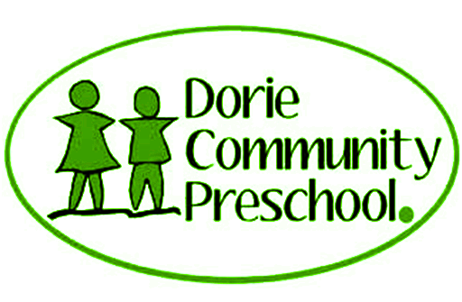
Mission Statement
Our pre school has been created by our community for our community. It is based in our unique rural setting and designed as a place of discovery where children can try out their ideas, pursue their questions and theories as well as follow their own individual curiosity through a curriculum that is based on the National Framework Te Whaariki.

Philosophy
Here at Dorie Community Preschool , we have been built for our community, by our community. have a unique rural setting which allows our tamariki to learn by exploring and discovering their environment.
We have created an environment where our tamariki are respected and trusted for their inner potential and celebrated for who they are and where they come from. Zealand has a unique bi cultural heritage which is reflected in our learning environment, seen through practices such as Te Reo Maori, Tikanga, and providing our tamariki with the opportunity to learn and develop respect for both partners of TeTiriti O Waitangi.
Whanaungatanga is valued here. We have an door policy, family and whanau are always welcome to visit the centre and participate in their child's learning journey.
We believe that learning takes place when tamariki have a strong sense of well being and belonging. Whāriki is our guiding document and we work towards meeting the aspirations of this curriculum where we believe, all of our grow up as, confident learners and communicators, healthy in mind, body and spirit, secure in their sense of belonging and in the knowledge that they make a valued contribution to society.

Poipoia te kakano kia puawai—Nurture the seed and it will blossom.

